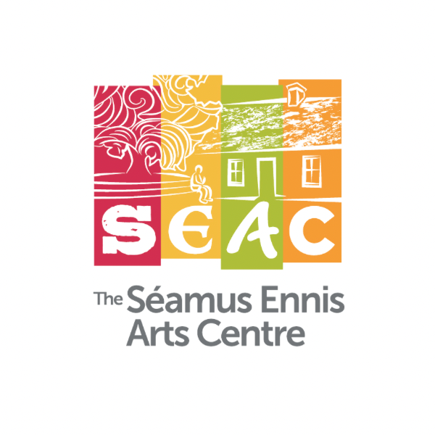
Equality, Diversity, and Inclusion Policy
January 2024

Introduction
The Séamus Ennis Arts Centre (SEAC) is committed to promoting and maintaining an inclusive and diverse workplace that respects the rights and dignity of all individuals, artists, and audiences with whom we work. We believe that embracing diversity, equity, and inclusion is essential to our success. This policy outlines our commitment to fostering an environment that is free from discrimination, harassment, and bias, and where all employees and stakeholders are treated with respect and fairness.

Policy Statement
SEAC is dedicated to the principles of equality, diversity, and inclusion in all aspects of our operations, including recruitment, employment, programming, audience development, customer relationships, music school, and industry collaboration and partnerships. We are committed to:
Providing Equal Opportunities | - Ensuring that all employees, artists, job applicants, and stakeholders are treated fairly and without discrimination, regardless of race, ethnicity, national origin, gender, sexual orientation, religion, disability, age, or any other characteristic protected by law.  - Seeking to attract a diverse range of talent as opportunities become available.  - Promoting flexible work arrangements and remote working options that support work-life balance and accommodate employees with differing circumstances and diverse needs.
Embedding Inclusion | - Integrating inclusion and diversity into all elements of planning, programming and service delivery.  - Leading by example – senior executives are responsible for setting the tone, leading by example, demonstrating the values of diversity and inclusion in their behaviour and decision-making  - Ensuring provision of diversity and inclusion training as required to raise awareness and foster an inclusive workplace.  - Creating an inclusive work environment that values the unique perspectives and contributions of each person  - Promoting open communication and collaboration  - Ensure actionable steps to promote diversity and inclusion are provided within the company’s Strategic Plan  - Collaborating with partners to develop and implement initiatives that promote diversity and inclusion
Eliminating Discrimination and Harassment | - Ensuring that there is no discrimination, harassment, or bullying in the workplace and taking immediate and appropriate action against any form of discrimination, harassment, or bullying identified.
Ensuring Accessibility | - Ensuring that our venue, programming, events, services, and promotions are accessible to individuals with disabilities and additional needs.
Promoting Respect | - Developing and maintaining a culture where all employees are responsible for treating their colleagues, audiences, artists, children and young people and industry partners with respect and valuing diversity.

Policy Review
SEAC will review this policy annually to ensure its effectiveness and make necessary improvements.

Communication
The policy will be communicated to all employees, artists, stakeholders, service users and collaborators and will be made available to our audiences and the public on our website.
SEAC is dedicated to creating an inclusive, diverse, and equitable environment in the arts and cultural sector in Fingal. We believe that this commitment enhances our commitment to our employees, artists and audiences, enhancing our ability to serve our audiences effectively.

Lauren O’Toole
DIRECTOR

Date: ______________________

